Job Builder
For NON-represented staff only
Login to: | https://Jobbuilder.ucmerced.edu
Search Job Standard for appropriate classification | A Job Standard is not a position description but a generic pre-defined template which describes various attributes of a job including the Scope, Key Responsibilities and Knowledge and Skills requirements of a specific Job level within a Job Function. A Job Standard is a starting point used to help build an actual Position Description.  All Job Standards are categorized by Job Family, Job Function, Category and Job Code.
Create Position Description | The first way to create a Position Description is to click the white and blue icon, in the column labeled Action, on the same row as the Job Title the Position Description will be built from on the search results page:  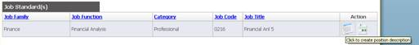  The second way to create a Position Description is from the page where you can view the Job Standard. When viewing a Job Standard click on the button in the upper left of page labeled Create Description.  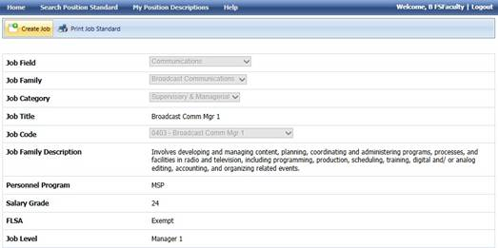  There is a third option that will allow you to create a Position Description that involves copying a Position Description that has already been created that is in your library. This method is covered in Section 7.3 of this user guide  Position Description Elements  Section 4.3 of this manual presented the many elements that make up a Job Standard. A Position Description has all of the same elements plus additional elements that must be reviewed and completed. Below is a list of the additional elements that make up a Position Description and a brief description of each one.  Additional Elements on a Position Description  Form Name – This is the system assigned naming convention for each Position Description saved in the application. The naming convention uses a combination of information from the Position Description itself.  Working Title – This is department select working tile entered when the Position Description was created.  Employee Name – This is the name of the employee that is assigned to this position. If this is for a new or vacant position, the name Vacant is often used as a placeholder.  Position Control Number – Is a unique number (sometimes alpha/numeric) assigned to each Budget approved position. Currently this is placeholder and is not used.  Department – This is the department to which the position is being assigned.  Organization – This is automatically completed based on the Department selected.  Division – This is automatically completed based on the Department selected.  License Certifications – Any specific Licenses or Certification required for the position should be indicated in this section.  Physical Requirements – This is a list of the most common physical requirements that may be required for a position as well as the frequency of occurrence.  Mental Requirements – This is a list of the most common mental requirements that may be required for a position as well as the frequency of occurrence.  Environmental Requirements – This is a list of the most common environmental requirements that may be required for a position as well as the frequency of occurrence.  Direct Supervision – Payroll Job Titles, or groups of titles, and the FTE a position has direct supervision over should be listed in this section.  Supervision Received – Denotes the type of supervision a position generally receives.  Critical Position – Indicates if a position can be classified as a critical position.  Date Created – Automatically indicates the date a specific Position Description was created.  Check Boxes – At the bottom of the Key Responsibilities, Knowledge Skills and Direct Supervision section there is a check box that will allow you to add more rows if needed.  Filling In The Position Description Form  When a Position Description is being created, several items already have text pre-filled from the Job Standard. This is generic text that requires modification when building any specific position description. Any beige colored area (similar to the picture below) can be edited when filling in a Position Description.  Filling In The Position Description Form  When a Position Description is being created, several items already have text pre-filled from the Job Standard. This is generic text that requires modification when building any specific position description. Any beige colored area (similar to the picture below) can be edited when filling in a Position Description.  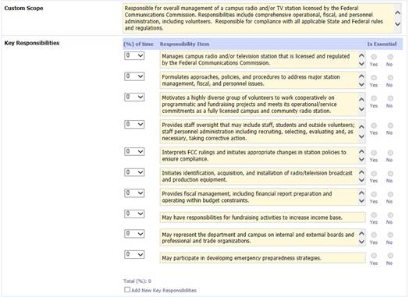  At the bottom of some sections there is a check box to Add New rows. Clicking on this check box will do just that: add more rows to that area of the position description. You are allowed a maximum of 15 rows in the Key Responsibilities area of the Position Description.

